C:\Users\domita\AppData\Local\Microsoft\Windows\Temporary Internet Files\Content.IE5\QSQ03687\MC900155555[1].wmf

[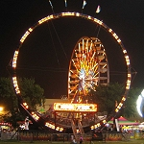](http://armstrongshows.com/rides/images/28L.jpg)[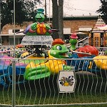](http://armstrongshows.com/rides/images/38L.jpg)[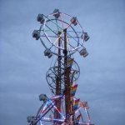](http://armstrongshows.com/rides/images/70L.jpg)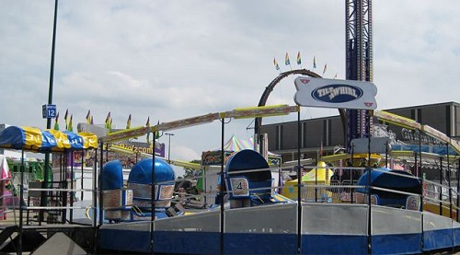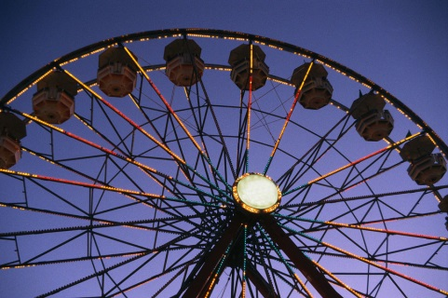[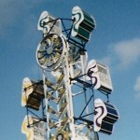](http://armstrongshows.com/rides/images/30L.jpg)[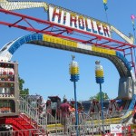](http://armstrongshows.com/rides/images/27L.jpg)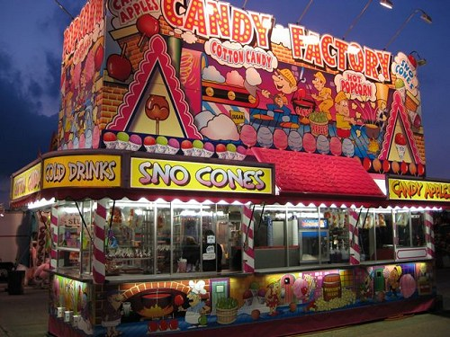

**Even More New Rides!!**

Welcome to the Todd Armstrong Shows - Master of the art of fun! Todd Armstrong Shows provides carnival rides, games, and food to fairs, festivals, and celebrations across the southern states and areas of the Midwest. The vast variety of thrill rides such as the Super Shot and Himalaya, along with family favorites such as the Gondola Wheel and Tilt-A-Whirl, plus a complete kiddy land with rides like the Carousel and Circus Train are sure to provide enjoyment for patrons of all ages!

**Master of the Art of Fun!!**

**Todd Armstrong Shows**

**Returning to**

**the Marshall County Fair!**

**Great Family Fun!!!**

**Marshall County Fair**

**July 22nd -26th**