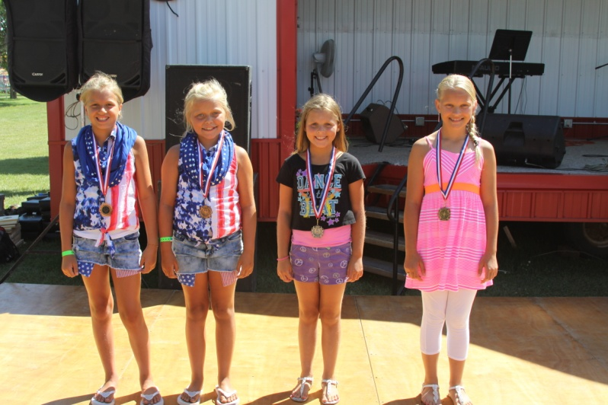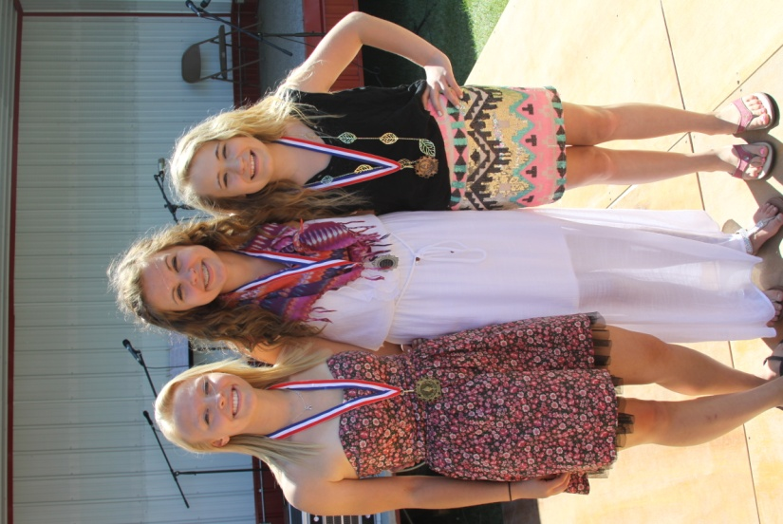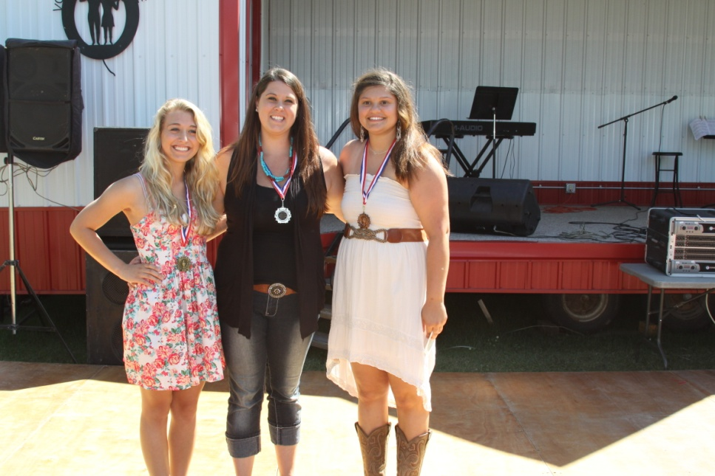**MARSHALL COUNTY FAIR TALENT CONTEST**

**Sat. July 23rd, 2pm**

**Singers, dancers,   
musicians, comedians and entertainers are encouraged to share their talents !!!   
  
 For more info:** www.marshallcountyfair.org

**CATEGORIES  
  
0-12 Years**

**13-18 Years**

**19 and over open class**

**1st – 3rd place prizes for each category**

**For talent contest information or to register please call or e-mail   
  
Josh Whitlow 218-686-1269**

**[josh.whitlow@digikey.com](mailto:josh.whitlow@digikey.com)   
   
or visit our website at** [**www.marshallcountryfair.org**](http://www.marshallcountryfair.org)

**Registration deadline is July 15th**